**25/03/2020 ATHAVALE CLASSES**

**Time:- 45 min Logic, LPP Marks:- 60**

1) The simplified circuit for the following circuit is

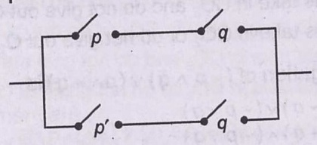 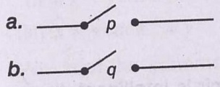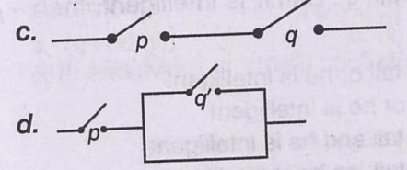

2) Consider the circuit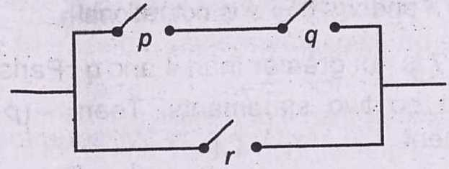 Then, the current flow in the circuit is a)  b)  c)  d) None of the above

3) Equivalent circuit for the logical expression is 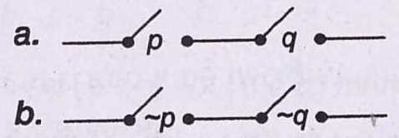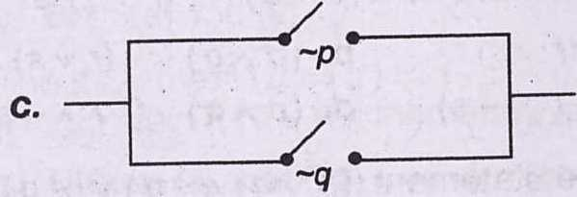 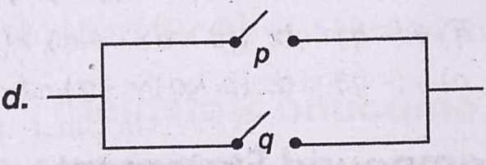

4) Let S be a non-empty subset of R. Consider the statement P: There is a rational number such that X > 0.Which of the following statements is the negation of the statement P? a) There is a rational numbersuch that 

b) There is a no rational numbersuch that 

c) Every rational numbersatisfies  d) and is a not rational.

5) Dual of  is

a) b) c) d) None of these

6) Which of the following statement has the truth value F?

a) A quadratic equation has always a real root

b) The number of ways of seating 2 persons in two chairs out of n persons is P(n,2)

c) The cube roots of unity are in GP d) None of the above

7) If p, q, r are single propositions with truth values T,F,F, then the truth value of is a) T b) F c) cannot find d) None of these

8) The output of the following circuit is

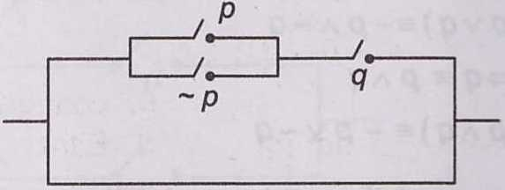 a) p b) q c)  d) p + q

9) is a

a) tautology b) contradiction c) Neither (a) nor (b) d) Either (a) or (b)

10) If p : A man is happy and q : A man is rich. Then, the statement “If a man is not happy, then he is not rich” is written as a)  b) c) d) 

11) Given statement is ‘if x = y, then x2 = y2, and the statement are (i) If , then  (ii) If ,then (iii) or  (iv) If then  Which of the statement are equivalent to the given statement?

a) (i) and (iii) b) (ii) and (iv) c) (i) and (iv) d) (iii) and (iv)

12) The constraintsdefines

a) bounded feasible space b) unbounded feasible space

c) both bounded and unbounded feasible space d) None of these

13) The region represented by the in equation system is a) unbounded in first quadrant b) unbounded in first and second quadrants

c) bounded in first quadrant d) None of the above

14) A wholesale merchant wants to start the business of cereal with ₹24000. Wheat is ₹400 per quintal and rice is ₹ 600 per quintal. He has capacity to store 200 quintal cereal. He earns the profit ₹25 per quintal on wheat and ₹ 40 per quintal on rice. If he stores x quintal rice and y quintal wheat, then for maximum profit the objective function is a)  b)  c)  d)

15) Which of the terms is not used in a linear programming problem?

a) Optimal solution b) Feasible solution c) Concave region d) Objective function

16) The shaded region for the inequality is

a) to the non-origin side of  b) to the either side of 

c) to the origin side of  d) to the neither side of 

17) The graphical solution of linear inequalities and , is

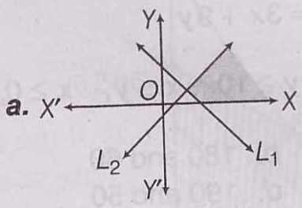 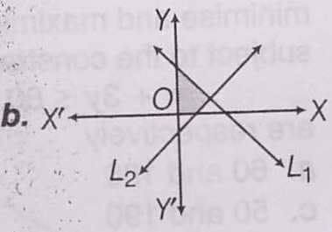 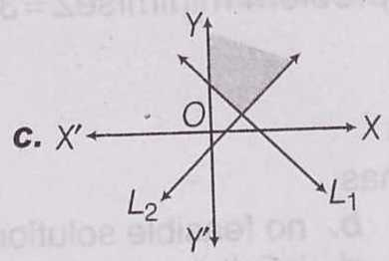 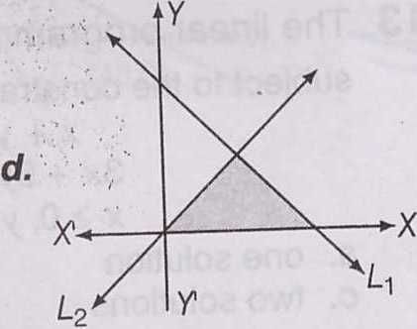

18) The minimum value of the objective function Z = x + 2y subject to the constraints, subject to the constraints, occurs

a) at every point on the line  b) at every point on the line 

c) at every point on the line  d) at every point on the line 

19) Consider the following statements (i). If the feasible region of an LPP is unbounded, then maximum or minimum value of the objective function Z = ax + by may or may not exist.

(ii) Maximum value of the objective function Z = ax + by in an LPP always occurs at only one corner point of the feasible region.

(iii) In an LPP, the minimum value of the objective function Z = ax + by is always 0, if origin is one of the corner point of the feasible region.

(iv) In an LPP, the maximum value of the objective function Z = ax + by is always finite.

Which of the following statement are true?

a) i and iv b) ii and iii c) i and iii d) ii and iv

20) The corner points of the feasible region determined by the system of linear constraints are (0, 10), ( 5,5) (15,15), (0,20). Let Z = px + qy , where p, q > 0.Then the condition on p and q so that the maximum of Z occurs at both the points ( 15, 15) and ( 0, 20), is.

a) p = q b) p = 2q c) q = 2p d) q = 3p

21) For an LPP, minimise Z = 2x + y subject to constraints and then Z is equal to a) 0 b) 1 c) 2 d) 12

22) The linear programming problem minimisesubject to the constraintshas a) one solution b) no feasible solution c) two solution d) infinity many solutions

23) Consider the inequalities. Which of the following point lies inside the solution set? a) (1,3) b) (1,2) c) (1,4) d) (2,2)

24) The corner point method for bounded feasible region comprises of the following steps

(i) When the feasible region is bounded, M and m are the maximum and minimum values of Z. (ii) Find the feasible region of the linear programming problem and determine its corner points. (iii) Evaluate the objective function Z = ax + by at each corner point. Let M and m respectively be the largest and smallest values of these points. The correct order of these above steps is a) iii,i,ii b) ii,iii,i c) ii,i,iii d) i,iii,ii

25) A company recruits male workers (x) and female workers (y) under the condition that the company must have at least 2 female workers and total number of workers should not be more than 9. then x and y can be related as :

a) y ≥ 2, x +y ≤ 9 b) y ≤ 2, x + y ≤ 9 c) y > 2, x + y ≤ 9 d) y ≥ 2, x + y ≥ 9

26) If the statement : is false then the truth value of p,q and r are respectively a) F,F,T b) T,F,F c) F,T,T d) T,F,T

27) A firm manufactures two items A and B. The cost of manufacturing A and B is Rs. 500 and Rs. 600 per unit respectively. A firm has Rs. 100,000 to invest and store capacity of 80 units. Taking x and y as number of units produced, the inequalities for above situation are:

a) 500x +600y <100,000 x + y<80, x ≥ 0,y ≥ 0 b) 500 x +600y ≤100,000 x + y≤ 80,x ≥ 0,y ≥ 0

c) 500x +600y ≥ 100,000 x +y ≥80 d) 500x + 600y > 100,000 x +y > 80